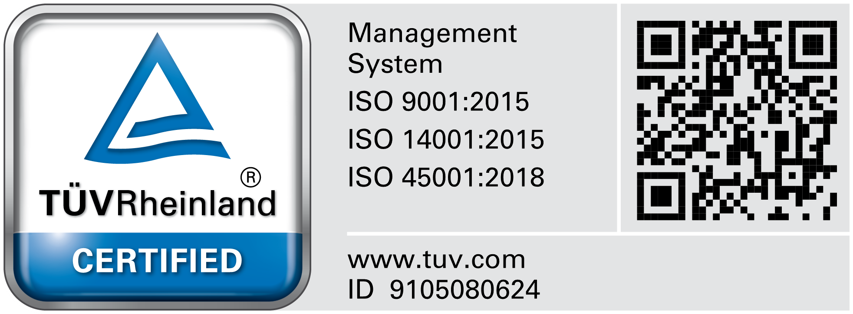

Hanna Instruments SRL
Romania, Salaj, Nusfalau, Str. Hanna, Nr. 1
Tel.: +40/260/607700; Fax: +40/260/607739
Document No: MR-
Material Requisition

Section 1: Made by: From production line no./department:

today:

Reason of the request:

Materials requested:

No. | Code | Description | WH stock | Std./W | Qty req. | M.U. | Qty dlvd. | Additional comments
1.
2.
3.
4.
5.
Section 1 will be filled up by production line leader.

Section 2: Processed by:
Approval | Name | Signature | Department | Name | Signature
Department Manager/  Requester |  |  | Warehouse
General Manager/ Delegate |  |  | Planning Completed
Planning Analyze
Section 2 will be filled up by warehouse and planning responsible

MR_rev.0.6._2020.05.14 | Page 1/1 | CONFIDENTIAL

